Introduction:
Who are the end users?
What problem does the digital media outcome solve?
What should users see/do when it works?
What digital technologies outcome am I developing?
Who are the end users and what must it do?
The users of my interface after it is complete could be schools and clubs to mark attendance. The problem that I am trying to solve with my interface is that sometimes teachers forget to take the role and It could be seen and a hassle, So as students walk into the class they can scan the barcode on there id card to be marked present. This also solves the problem of organisation, with this interface you can go on the calendar and plan events so you are prepared and organised. When users use the interface they should see a successfully working interface where you can go to the different pages, see the role scan you id card, and take down events on the calendar.
Work Log: Computer Science 2.4 Assessment
Date: | What I did today: | Evidence:
11/06/2026 | Today I was looking at colour palettes for my mobile smart attendance website. I found three colour palettes that both had contrast with dark colours mixed with light colour, so it is easy to see text. I am still deciding between the three as I need to see which one would best suit my mobile app. | 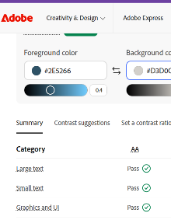  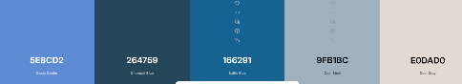  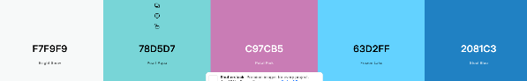  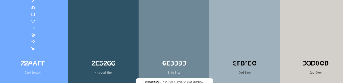
22/06/2026 | Today I started to work on my code. I first was working on the main smart attendance page for iPhone and laptops. The first component I was working on was adding a button to turn on the camera. After I did this I made it so that the camera picture displays on the page. After that I added in my colour palette so it has a nice aesthetic, and It was looking pretty good. My next step is to make the camera pick up on barcodes so I can link it so a name so they can mark themselves into a club. | 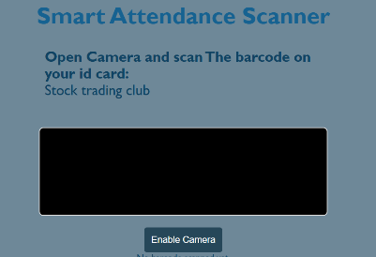  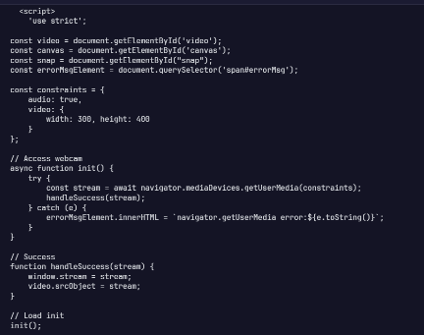
7/07/26 | Today I started to make the other pages and link them all together through the navigation bar. After I made the pages and put a navigation bar in all the pages I worked on my class list page and added names on this page to see who is in the class. I also added tabs on this page marked All, Present, and Absent. When you click on the tab it will soon show the people who have been marked present and the people who haven’t signed in yet. | 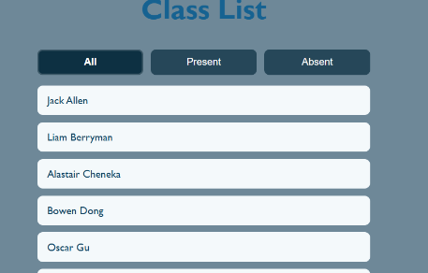  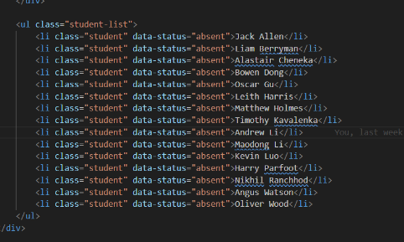
9/07/26 | Today I started to make it so the camera picked up on the barcode and could scan it so students could easily sign into there club without wasting any time of the class. This wasn’t a easy task for me as I had to do some searching to find out how to add this to my code. I did have to get the help of ai to how me figure out how to properly to add this to my code so it works successfully but we got it to work in the end. When doing this I realised that it was pretty similar to setting the RFID scanner up just in a way that the barcode is read. My next step from now it properly to link these codes to the class list so that when a barcode it read you can see who has been marked present and has scanned in yet. | 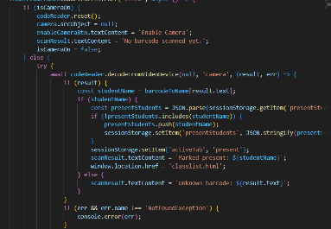  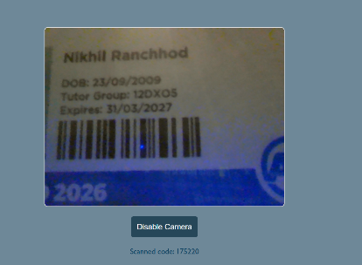  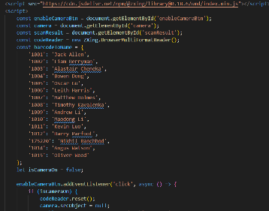
15/07/26 | Today I started to link the barcode code to the names on the class page. To complete this step of my program I first did some researched had searched up on how I was going to link the barcode keys to the names. When doing some research I helped my understand what I had to do and it made more realise that it somewhat was similar to the first assessment I did. | 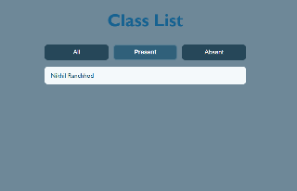  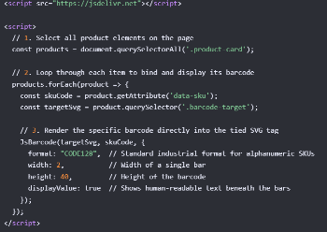  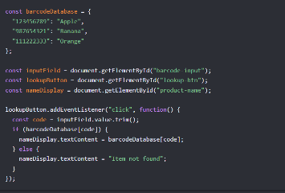
27/07/2026 | Today, it was the first day of the term and I didn’t to do much today because today we were going around the class and talking to other people about our assessment and seeing if we were doing similar things. When talking to other people it was interesting to see what they were doing and also gave more some other ideas on what I could do for my assessment to make it even better.
28/07/2026 | Today I mainly just worked on my planning. I was planning on what I was going to add to all these different pages so that I made sure I could keep track and stay organised with this assessment. To plan out this assessment I used a website called Trello, here I added different tasks that I was going to do and after I finished them I tick the box, this helps me as I won’t fall behind In my assessment and I can organise what I am going to do on some days. | 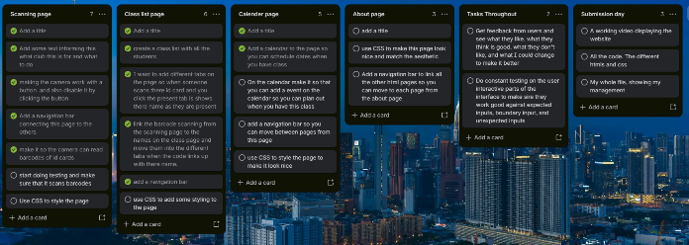
31/07/2026 | Today I started on adding some CSS to my pages. What I did today was I made the page look a little nicer by adding a cool border around my title with some shadows. This is a little feature, but I think it elevates the page so much as I think it makes the page a more comfortable place for students adding a nice calm aesthetic. | 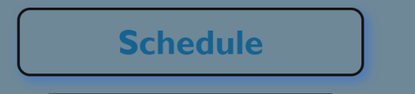  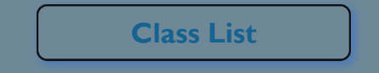  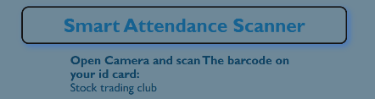
4/08/2026 | Today I was working on my calendar page and I was trying to add the calendar on to this page. After doing some research I found out what I had to do. so
5/08/2026 | Today I was working on looking at E exemplars to get ideas on what I had to add to me planning code and evidence to get a Excellence. I also went through and made sure that I had comments in the code to show evidence of my work
7/08/2026 | Today I had a change of plans and I was told to change the colours and aesthetic of my page to match my house colours more.
11/08/2026 | Feedback
12/08/2026 | Fonts | 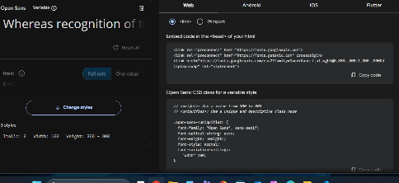  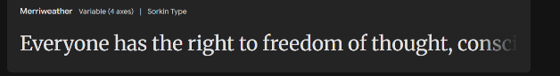  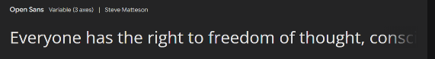
13/08/2026 | Events table | 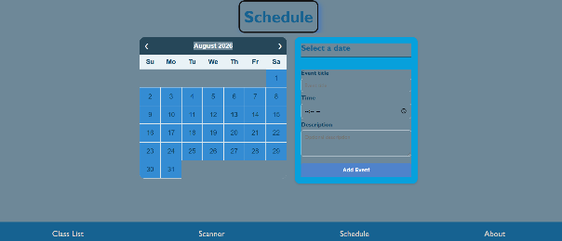

My advanced techniques:
Example of advanced techniques: | What it might look like: | Where in my project:
CSS custom properties / themes | :root tokens for colour, space, type
Responsive layout system | Mobile-first flex/grid + breakpoints | I have used media queries in my project when the screen starts to get smaller. I have added this advanced feature because it will help me to have a more user friendly interface where users can not be confused.

Media Conventions:
Implication: | Why is matters for my users: | How I addressed it:
Accessibility
Useability
Aesthetics
Consistency
User control and freedom

Planning:
My first start to planning was to create a Figma account and plan out and get ideas on how I was going to make and develop my website. This really
This is my Figma planning:
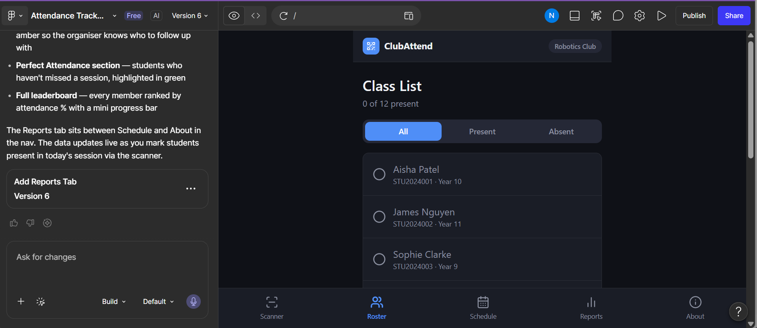
This is my Trello planning board:
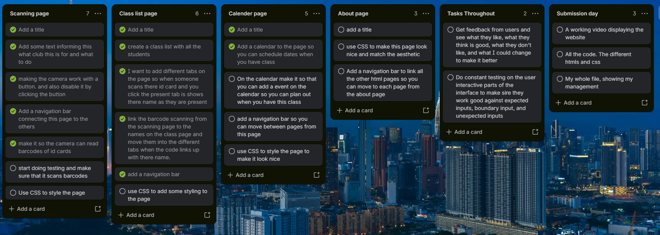

User feedback:
Date: | Name: | Feature/page you are looking at: | What you liked: | What you didn’t like: | what I should change: | Changes made after:
4/08/26 | Oscar b | Smart Attendance scanner | Layout looks good  Navigation bar works well | The colour scheme is hideous | Make the colour scheme less bland

My Focus point – Peer Feedback:
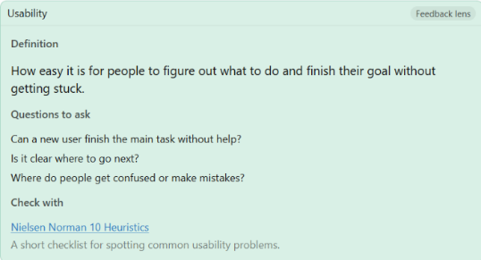
Kevin –
Date: | From: | Lens: | Feedback: | My Response/ change: | Evidence:
11/08/2026 | Kevin | Usability | Yes because it is very simple and easy to understand. It shows a lot of buttons with words that fully explain the purpose for the website.  I don’t get lost in any parts of it, design basically deserve full marks. Theres no place where you can get confused on because the website is simple and efficient

Testing table:
part: | What has been tested: Expected, Boundary, Invalid | Test input/ action: | Expected result: | Actual result: | Pass/fail | Notes/ changes made:
Scanning barcode with camera | Expected | I will scan my id card and see if it identities the key | When I scan the barcode of my id card it should give my the serial number | 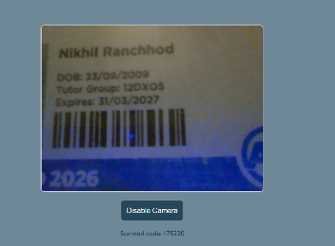  When I scan my barcode it gives me the serial number of my barcode | Pass
Spanning random dates on calendar (adding limit)
How testing improved the outcome:

Complex errors:
Date: | Error/Mistake: | Evidence:
9/07/26 | When I scanned a valid barcode, it displayed and message saying invalid barcode. After some time I realised that this was because I didn’t put my barcode key into my code so even if It was a valid barcode it would recognise it, so I was not able to be marked present. | 